Detecting Brain tumor Slices using MR Images and Classical Machine learning



**NAME OF THE PARTICIPANTS**

Vandana Sinha

Harsha Udayasri Chekuri

Anitha Shivaramaiah

Asmaa Alghamdi

**UNDER THE GUIDANCE**

**Dr. Zeenat Tariq**

PROF. OF DEPARTMENT OF COMPUTER SCIENCE AND ENGINEERING

University Of North Texas, Denton

**INDEX**

**TOPICS PAGE NO.**

|  |  |  |
| --- | --- | --- |
| **ABSTRACT** | **2** | |
| **INTRODUCTION** | **3** | |
| **MOTIVATION** | **4** | |
| **SIGNIFICANCE** | **5** | |
| **OBJECTIVE** | **6** | |
| **FEATURES**   * **Related Work (Background)** * **Dataset** * **Detail Design** | **7** |  |
| * **FLOWCHART FOR DATA ANALYSIS AND ANALYTICS** | **8-10** |
| * **ANALYSIS** | **11-13** |
| * **VISUALIZATION** | **14** |
| * **ANALYTICS** | **14** |
| * **DATA PREPARATION** | **15** |
| * **IMPLEMENTATATION** | **16** |
| * **PROJECT MANAGEMENT** | **17** |
| * **REFERENCES** | **18** |

# 

# ABSTRACT

*Gliomas, are primary brain tumors, that are developed from glial cells, which are the most frequent kind of primary brain tumors1 Detecting gliomas using magnetic resonance imaging (MRI) and Machine Learning (ML) can aid in estimating their aggressiveness and response to treatment.1 Glioma detection nowadays is primarily reliant on imaging correlates of histopathological findings. Additionally, multiple MRI sequences (T1 pre-contrast, T1 post-contrast, Flair and T2w images) that provide variable tissue contrast are used for detecting gliomas at the same time.2*

## INTRODUCTION

One of the most difficult difficulties the world faces today is a brain tumor, which is one of many diseases in medical science. A brain tumor is the growth of uncontrolled cells in the brain. Medical imaging techniques such as Magnetic Resonance Imaging (MRI) can detect tumors, however, it has the limitation of not being able to detect tumors smaller than 3 mm. As a result, segmentation is one of the most widely utilized tools in medical science for reliable brain tumor analysis. One approach for dividing a picture into areas is segmentation. Healthy tissues are separated from those that are harmed by segmentation. Quantitative analysis, accurate disease diagnosis, identification, and categorization of brain tumors are all made easier because of this. Given the abundance of tumor segmentation methods now accessible, more study in this field is necessary.

Manual detection is a monotonous and time-consuming task where a human intervention is required. Therefore, manual detection has several inter-rater and intra-rater variability, which results in detection that is not precise.1, 3, 4 The intra-rater and inter-rater variability of 20% and 28% respectively, have been reported for detecting brain tumors manually.5, 6 Accurate image-based detections also lies on the potential of the human specialist to transform the MRI signal from the multi-contrast images. As a result, automated machine learning techniques and algorithms for detecting gliomas can be designed to overcome the drawbacks.

To perform data analysis on The Central Brain Tumor Registry of the United States (CBTRUS) dataset for different brain cancers using Hadoop tools and to develop classical machine learning algorithms for detecting tumor slices in MR Images for the data analytics.

## BACKGROUND

In recent five years, the study, diagnosis, and examination of brain imaging disorders using MR images have been the primary focus of research for researchers, radiologists, and clinical professionals. The analysis of brain images is considered essential because diseases of brain tumors are deadly and cause many deaths in many countries. For example, according to the Cancer American Society [10], in 2021, 1,898,160 new cancer cases and 608,570 cancer deaths are reported in the United States.

Many researchers contribute to helping clinicians with the automatic detection of brain tumors. Numerous current works focus mostly on developing Machine learning and Deep learning algorithms for classification to automatically detect different types of brain tumors [12]. However, because of the complexity of brain tumor detection, the performances of each proposed method differ according to the used dataset, data preprocessing technique, the kind of algorithm, and extracted features. The domain needs more studies and methods to be offered to decrease the complexity and improve the performance of classification methods.

In this project, includes an analysis of Brain Cancers by Tumor type that has been done by using cancer Statistics Data in the US In order to obtain exact numbers of cancer diagnoses in the year between 2004-2018 in US and trying to investigate the factors and impacts of the patient's age, sex, and races on the cancer types and its rates. In addition, we develop machine learning algorithms for detecting tumor slices in MR Images for the cancer type gliomas.

## MODEL

Architectural model:

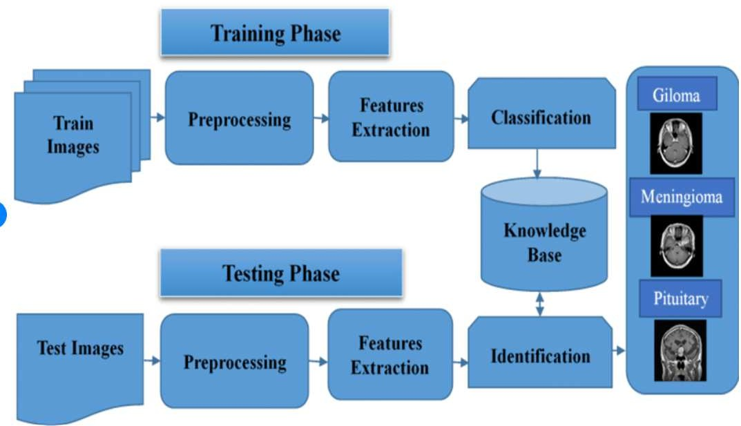

The deadliest disease is brain tumors, which have a life expectancy of only a few months in the most severe stages. Misdiagnosis of brain tumors will lead to inadequate medical treatment, diminishing the chances of life for patients. The precise diagnosis of a brain tumor is essential for designing an effective treatment approach that will cure and extend the lives of people with brain tumors. In the realm of machine learning, convolutional neural networks and computer- aided tumor detection systems have provided success stories and major improvements.

Deep convolutional layers, in contrast to prior neural network layers, automatically identify critical and robust properties from the input space. We use three convolutional neural network designs to categorize brain malignancies such as meningioma, glioma, and pituitary tumors in the proposed framework.

Workflow diagram:

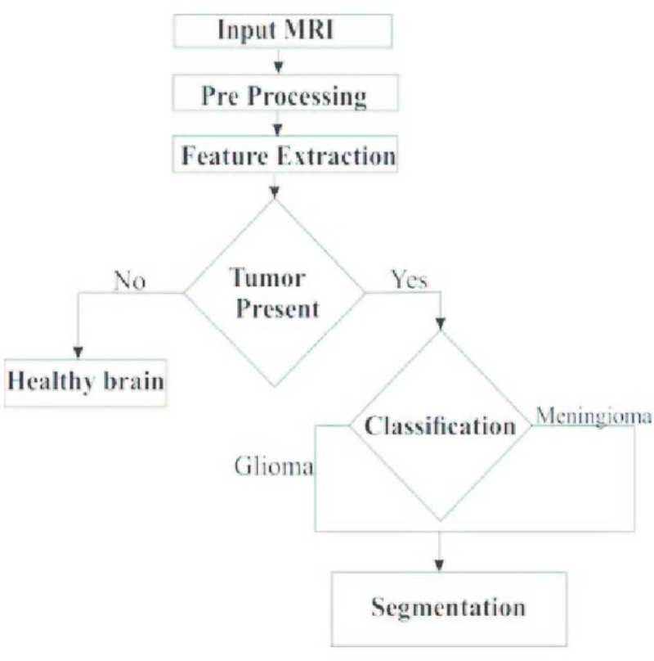

Following that, each study uses MRI slices from a brain tumor dataset to evaluate transfer learning techniques such as fine-tuning and freezing. To improve generalization of results, increase dataset samples, and lower the risk of overfitting, the MRI slices are subjected to data augmentation procedures.

As we can see that, the input is the MRI images and after the input data is obtained, we send it for pre-processing and extract the required features. In the extracted features, we can see that if a tumor is not present, it means that it is a healthy brain and if tumor is present, it means we need to check the type and with the help of classification we can predict the presence tumor cells, our interest is Gliomas. Finally, the segmentation is performed.

## DATASET

### Detail description of dataset

The first dataset we are using for the data analysis is the Brain Cancers - CBTRUS Tumor Type. It's taken from the Centers of Disease Control and Prevention [8]. The dataset has 13429 rows and ten columns of text data type. Cancer type, Year, Race, Sex, Age group, Rate type, Data type, Rate, Count, and Population are all the fields in the dataset. Incidence data is obtained from selected cancer registries that meet U.S. Cancer Statistics data quality standards. These registries cover 99 percent of the U.S. population.

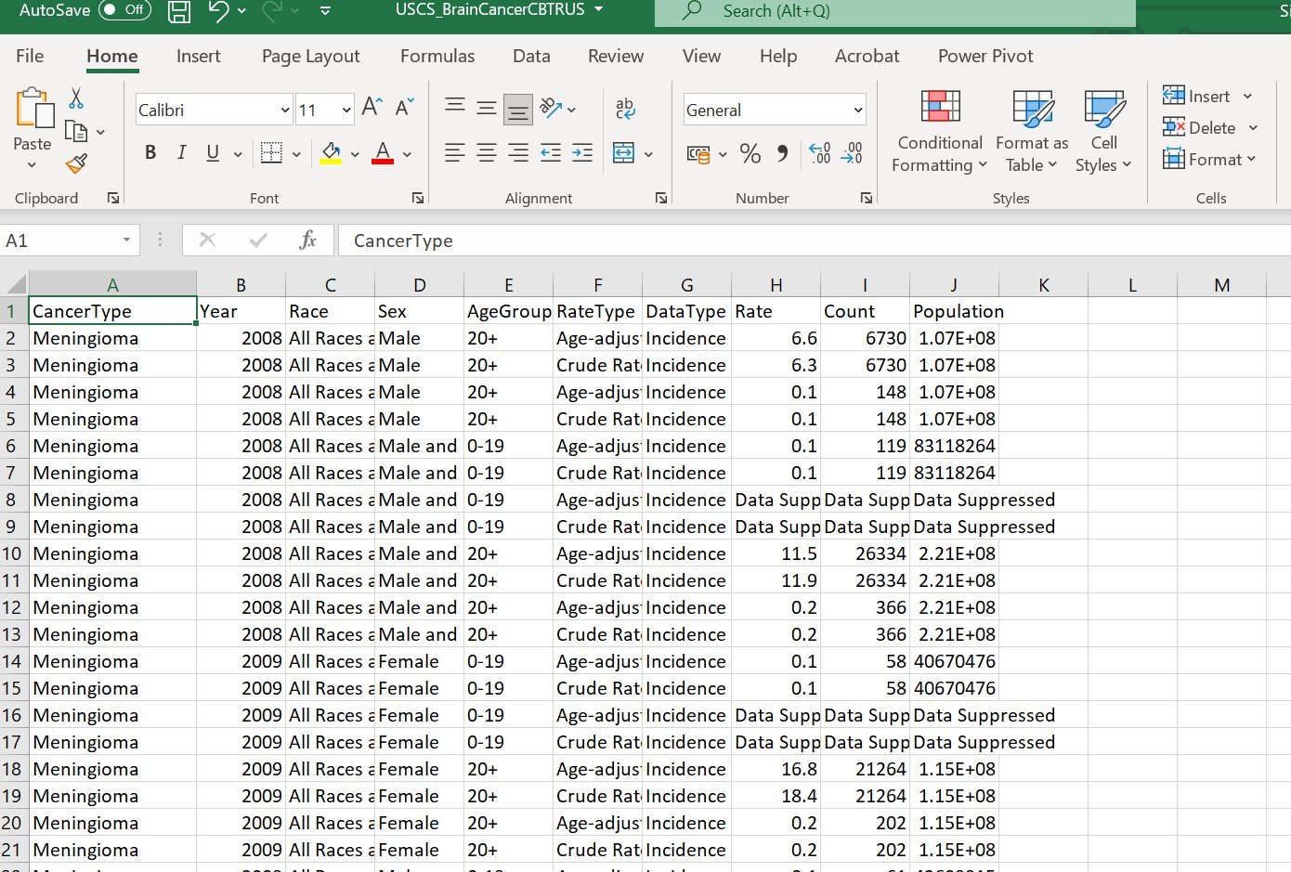

The second dataset used in this project is taken from the BraTS 2020 challenge, which included 369 participants' multi-institutional and multi-contrast (T1, T1c, T2, and FLAIR) pre- operative MRI images of glioma [9]. BraTS has always focused on evaluating the state-of- the-art for the brain tumor segmentation in the scans of MRI.

Imaging data description: All the scans are available as NIfTI files which are saved as .nii.gz which has the native T1, post contrast T1 weighted T1Gd, T2 weighted and T2 – FLAIR which is fluid attenuated inversion recovery volumes. all of these datasets has been segmented manually.

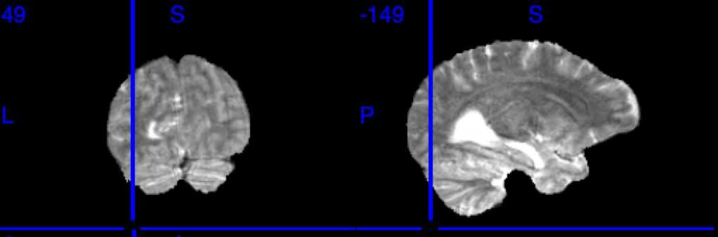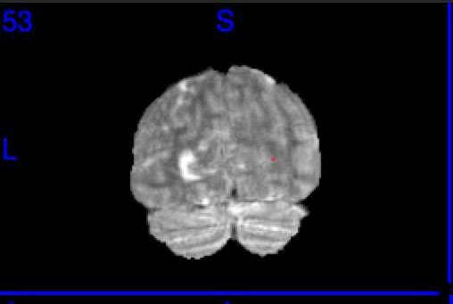

The above image shows a 3D picture of the MR images which doesn’t have tumor slices which is the _T2 subjects.

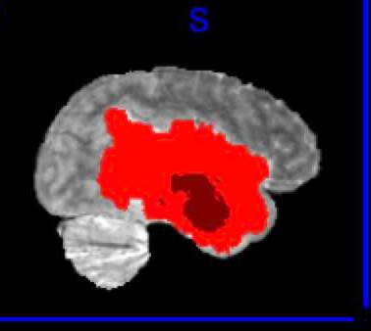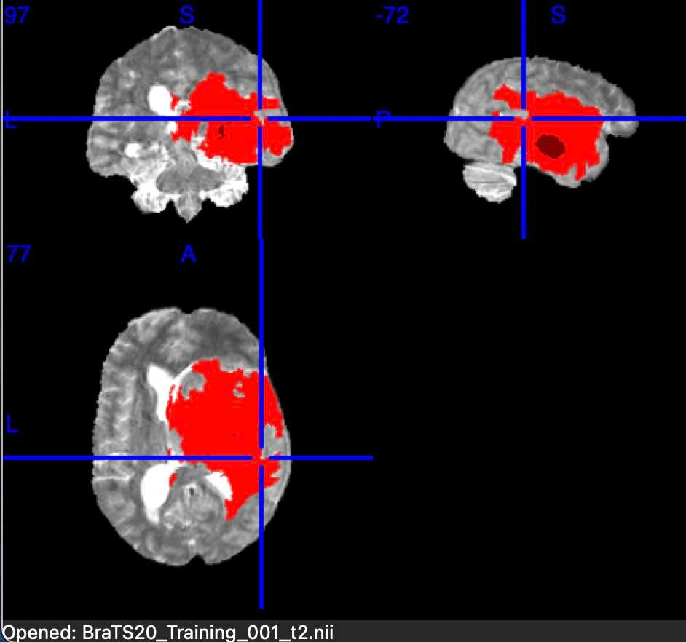

Red color voxels are the tumor slices for the BraTS training set 001. Which is the _seg mask

* **Methodology:**

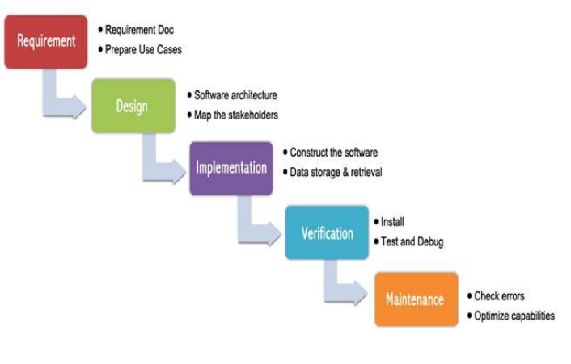

**Fig: Waterfall Methodology**

The waterfall methodology is a project management method that emphasizes a project's linear flow from start to finish. This methodology used to rely on meticulous planning, detailed documentation, and consistent execution, start early. It is divided into numerous distinct phases. Waterfall management does not enable to return to a previous phase until the preceding phase is completed, and each phase's completion is terminal. The only option to go back to a previous phase is to start over at the beginning. It makes the project easy to manage

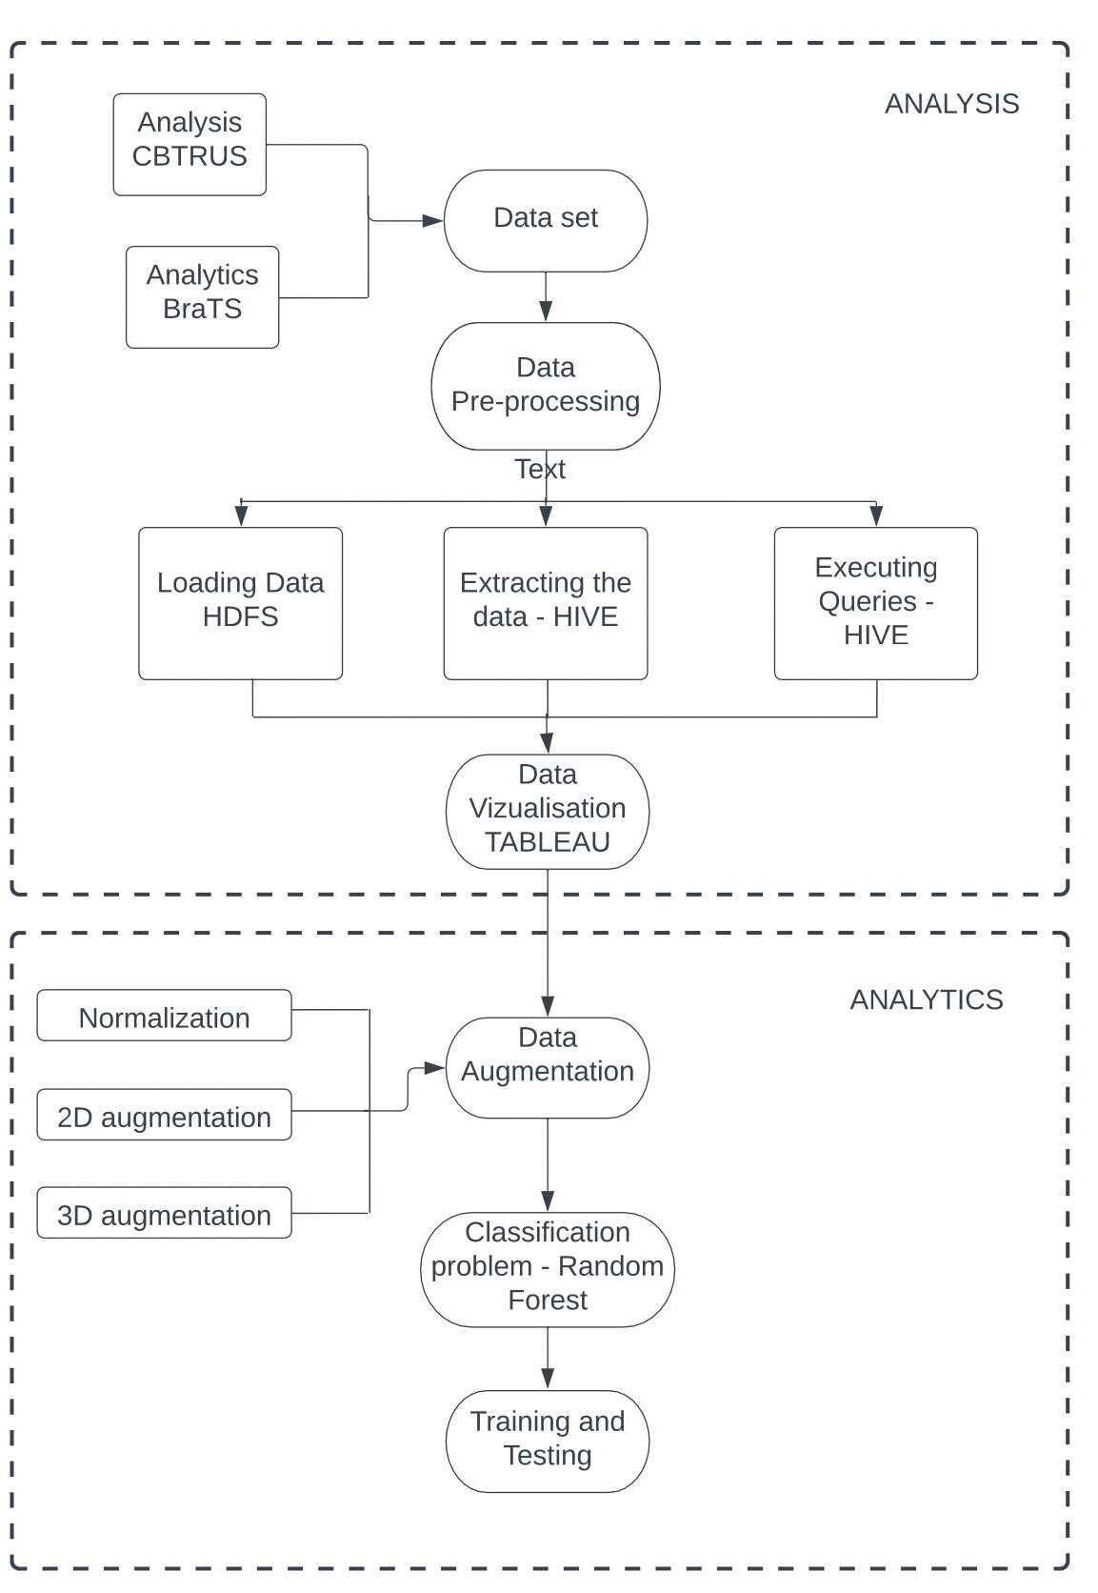

# Fig: Flowchart for Data Analysis and Data Analytics.

Initial data set consists of the data for the analysis and separate dataset fort the analytics part. For the data analysis we have loaded the data set into hadoop HDFS (Hadoop Distributed File system) environment. Using Hive. Hive acts as information warehouse system engineered within the hadoop classification system.

# ANALYSIS OF DATA:

* **Data Pre-processing for the first dataset**

***Creating Tables and Loading information:***

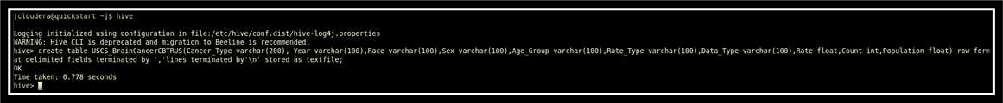

We the create the tables in HIVE and load the entire dataset.

The next step is to load the information into the table. Hive provides US with the utilities to load datasets from flat files hold on on HDFS.

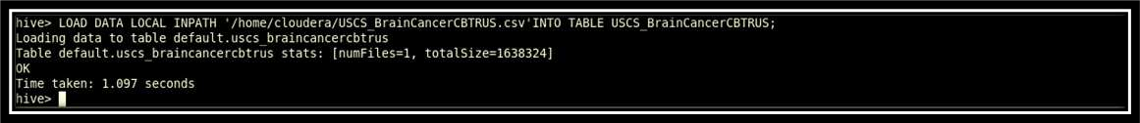

The command used to load the data is: LOAD DATALOCAL INPATH write INTO TABLE ;



The verification of knowledge obtaining loaded into the table may be administered by displaying the table contents or within the following method creating use of choose statement as shown below:



QUERYING ten queries were run on the info schema that got born-again into MapReduce jobs and dead

The list of queries area unit is given below:

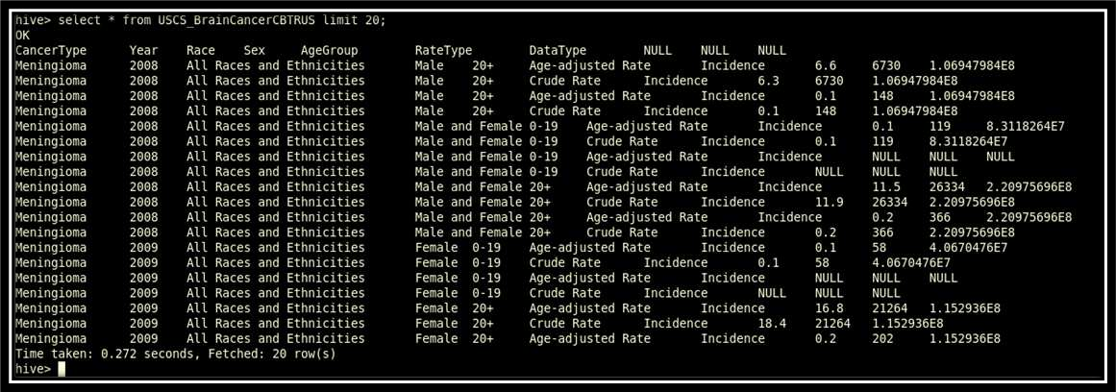

The list of queries executed in Hive are as follows:

### Extract all the cancer type from the dataset

We are listing out the cancer type from the sample population using below queries

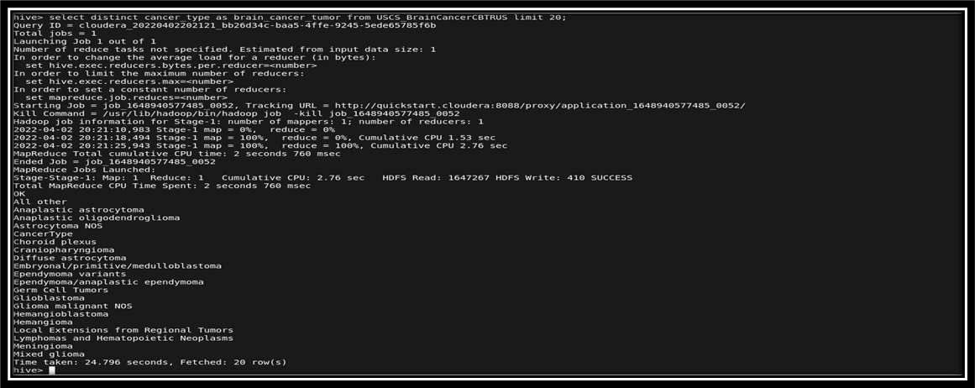

### 2a. Extract the cancer rate in Male in the year 2018 from the dataset

We are analyzing the Male cancer rate by fetching the latest set of records from the sample dataset.

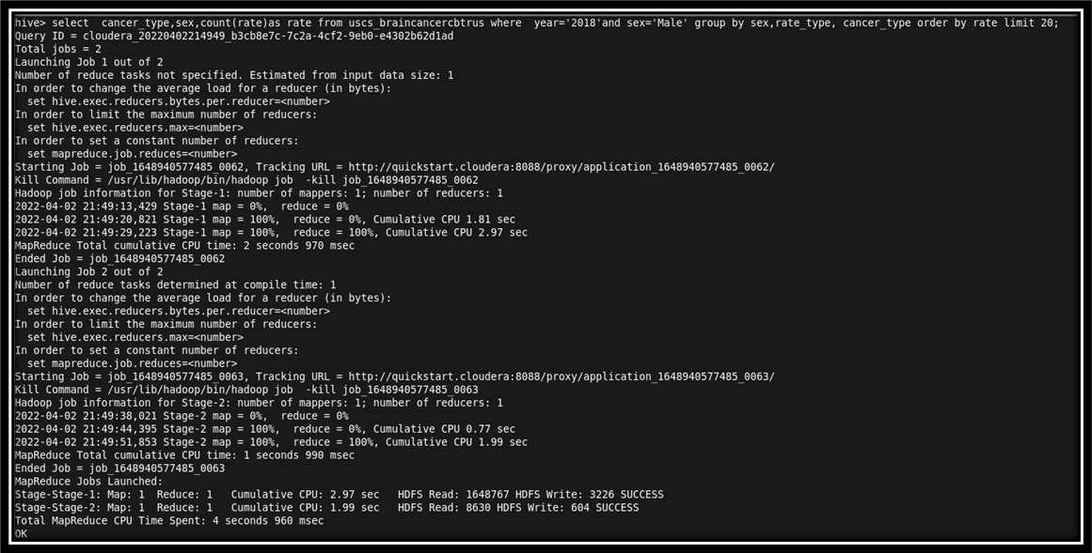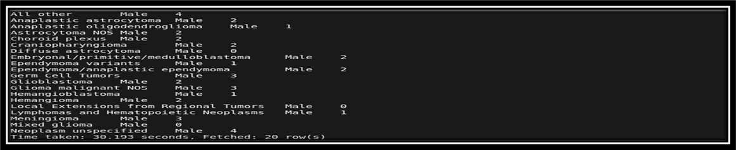

### Extract the cancer rate in Female in the year 2018 from the dataset

We are analyzing the Female cancer rate by fetching the latest set of records from the sample dataset.

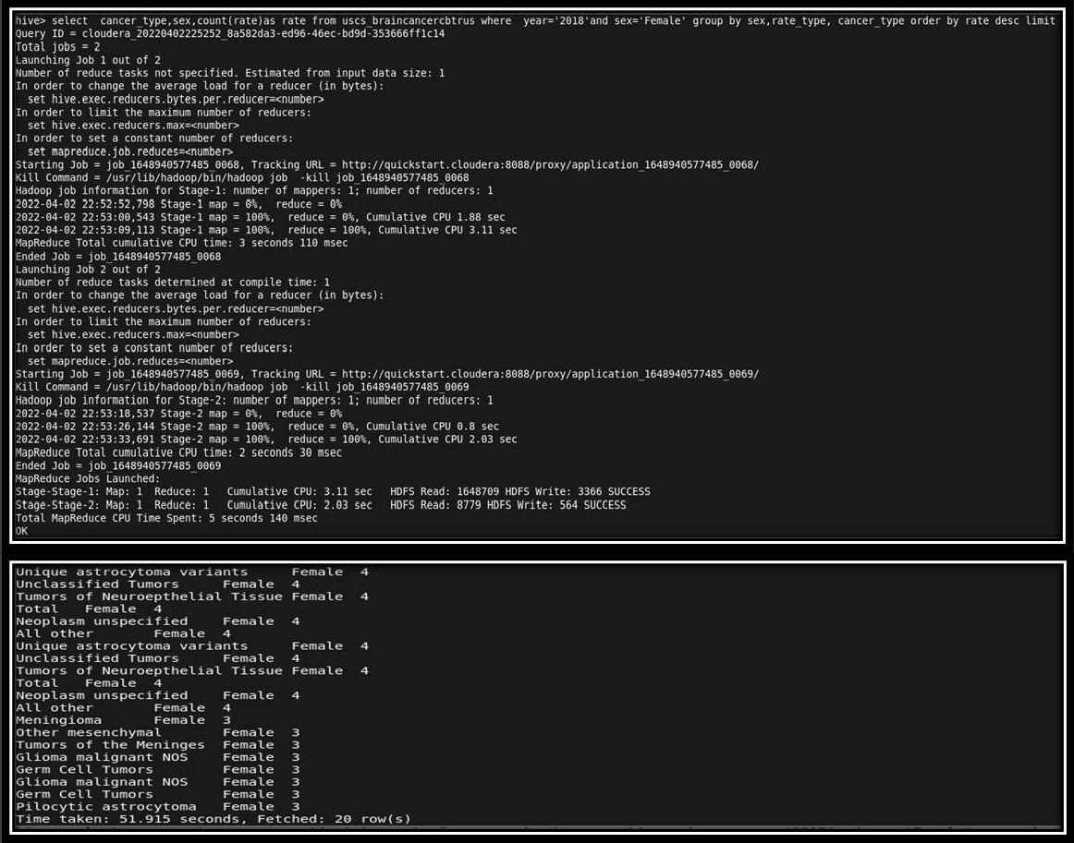

### Select total no. of brain cancer for Female detected in for year 2018

We are fetching the record to analyze the no.of female cancer patient from the latest set of sample population.

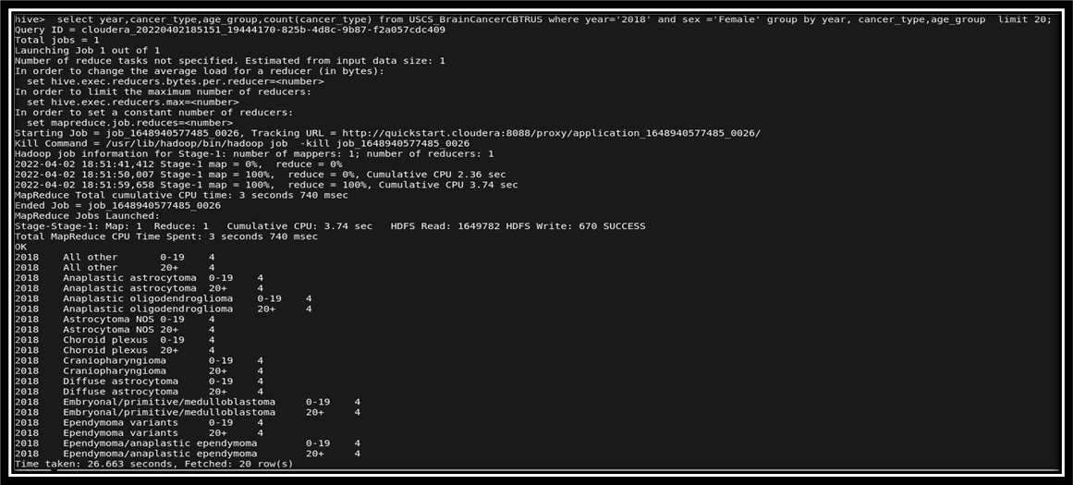

### Select most cancer_type common in females in 2018

We are analyzing the most common cancer type found in females for the latest set of population

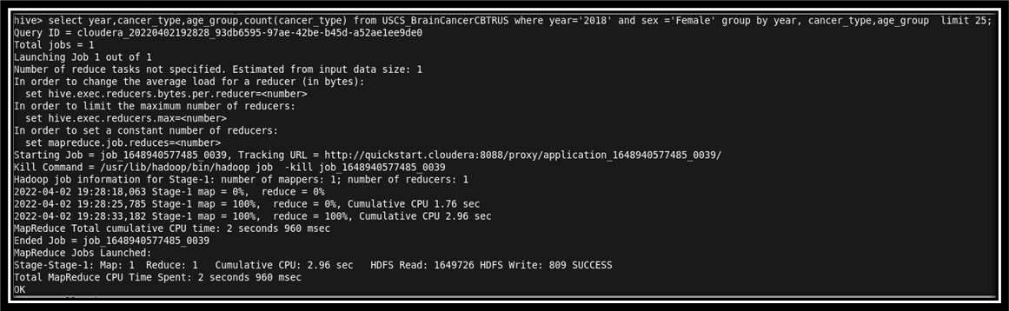

### At the Age group of 20+ what are cancer types most common in Male and Female.

Here we are taking the cumulative records of the common cancer type found in male and female of age group 20+

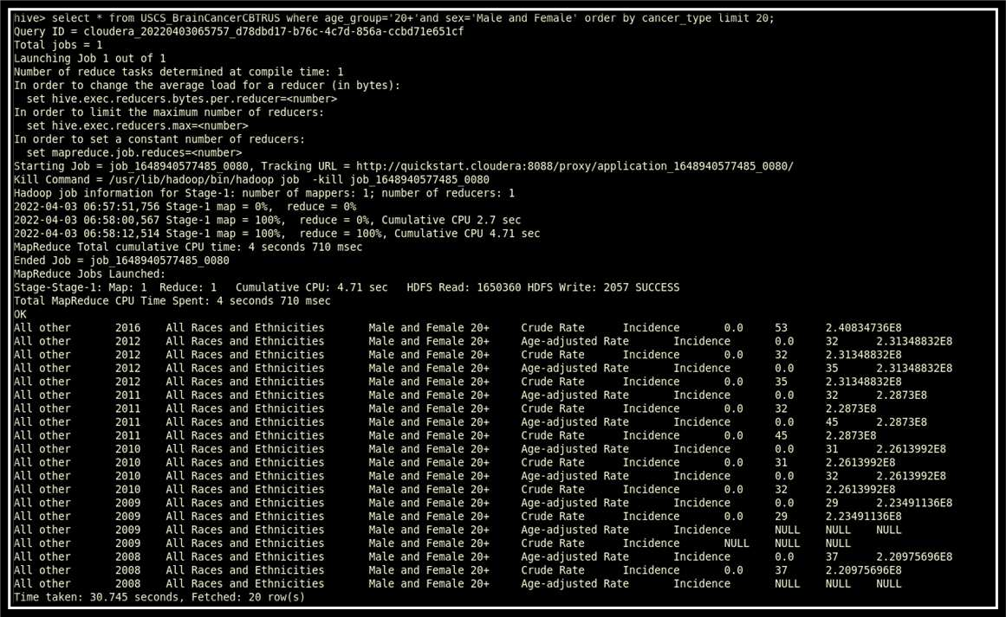

### Select for cancer type ‘Glioma’ for 20+ age group in the year 2018

Now coming back to glioma which is the primary brain tumor for our project so here we are fetching the latest set of records for glioma patients.

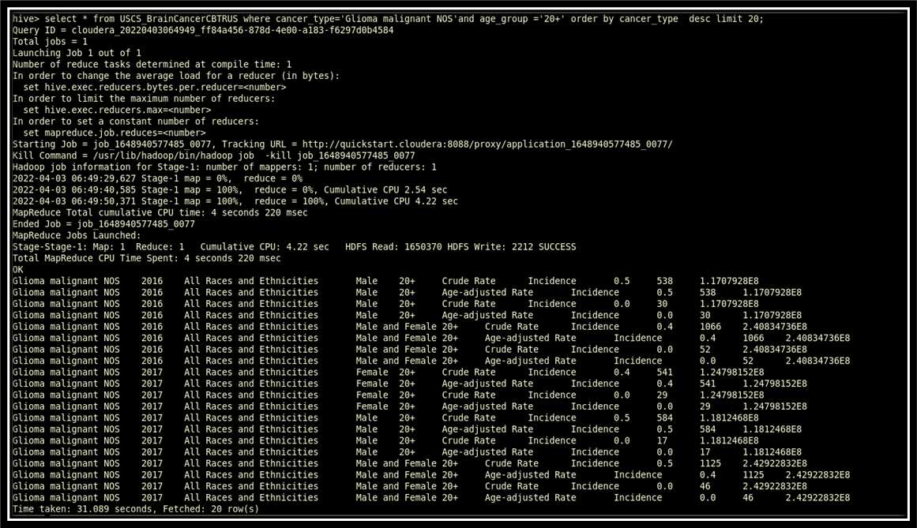

### Fetch the records for cancer type 'Glioma malignant NOS ‘from the population sample for the year 2018

Here we are extracting and analyzing the latest sample population for glioma cancer type.

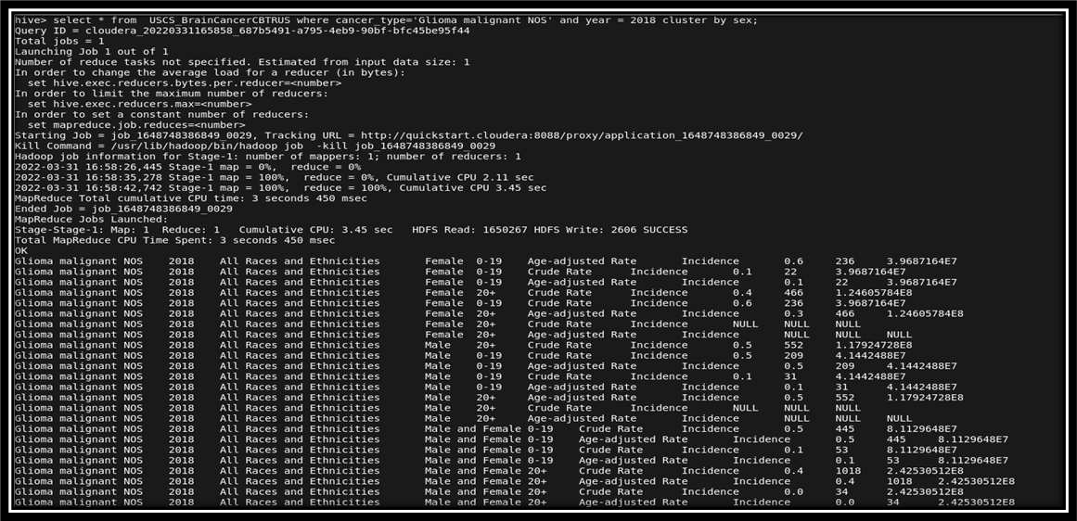

### Fetch rate and count of Glioma malignant NOS reported in 2018

In this part we are fetching the rate and count of glioma cases reported in the year 2018.

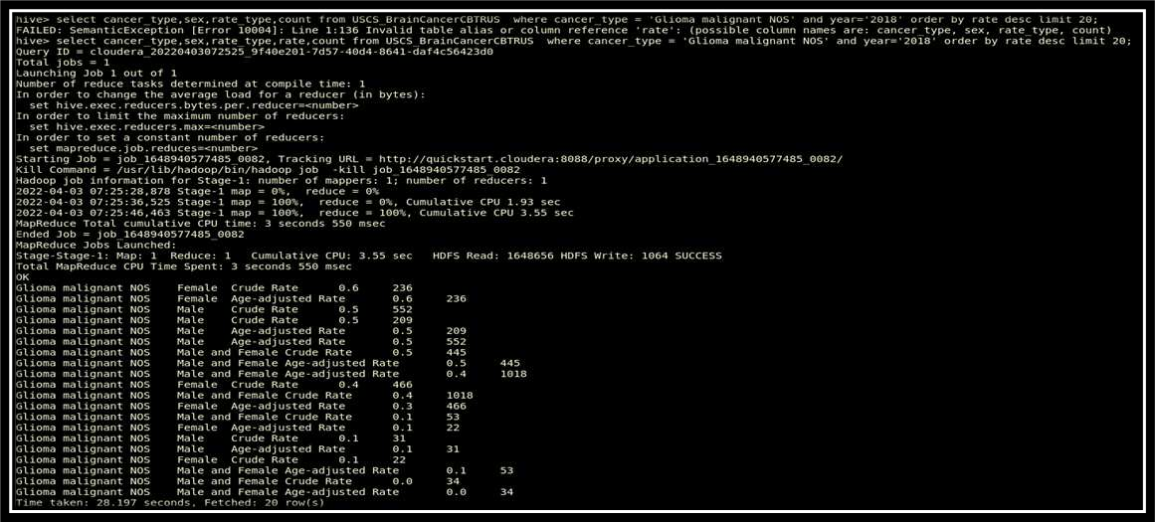

* 1. **Extract all the age group with cancer type ‘Glioma_malignant NOS’ from the population sample**

**Now we are going to capture glioma tumor records for all the age group from the sample data.**

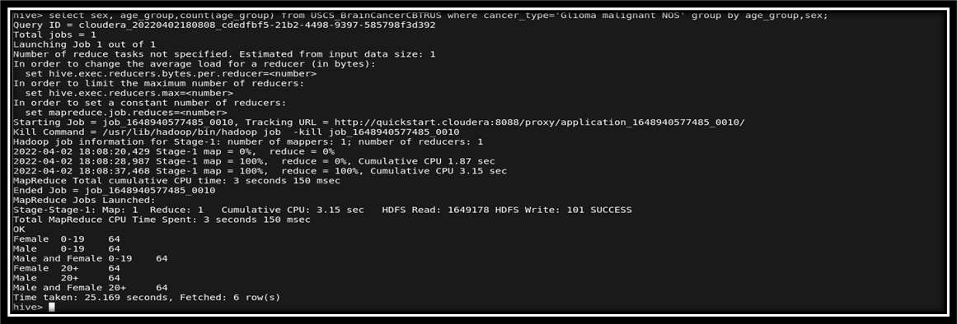

* 1. **Extract the entire population reported with cancer type ‘Glioma malignant NOS’ for the year 2018**

Taking a broad picture into consideration we will be extracting all the records reported for glioma in the latest year.

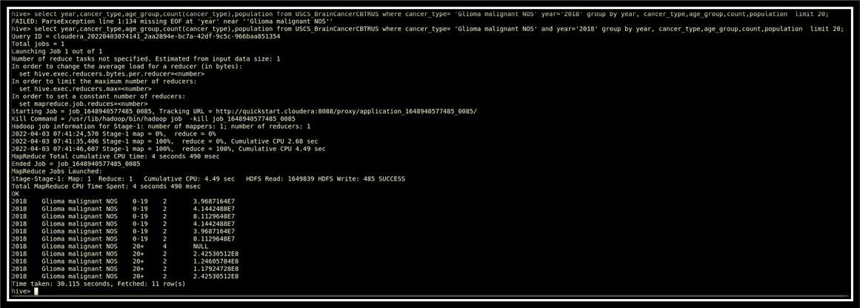

Querying and optimizing the dataset has given us the output for each partition. Based on the output, visualization of the dataset is implemented.

### Graph model:

**Implementation and preliminary results**

For Data Visualization we used the tool Tableau

**(Fig.1) All Cancer Types**

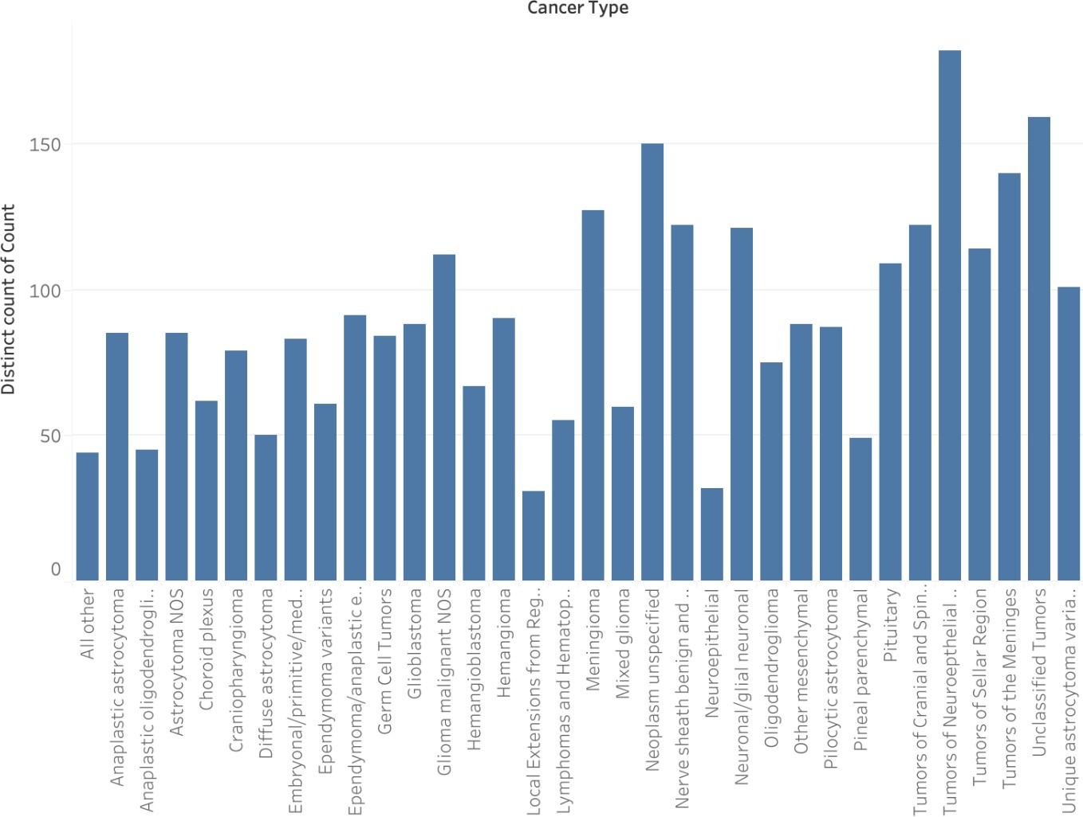

The results of extracting the data analysis displayed in Fig. 1. Shows all the cancer types that have been reported to the U.S. Cancer center from 2004 to 2018 along with their counts.

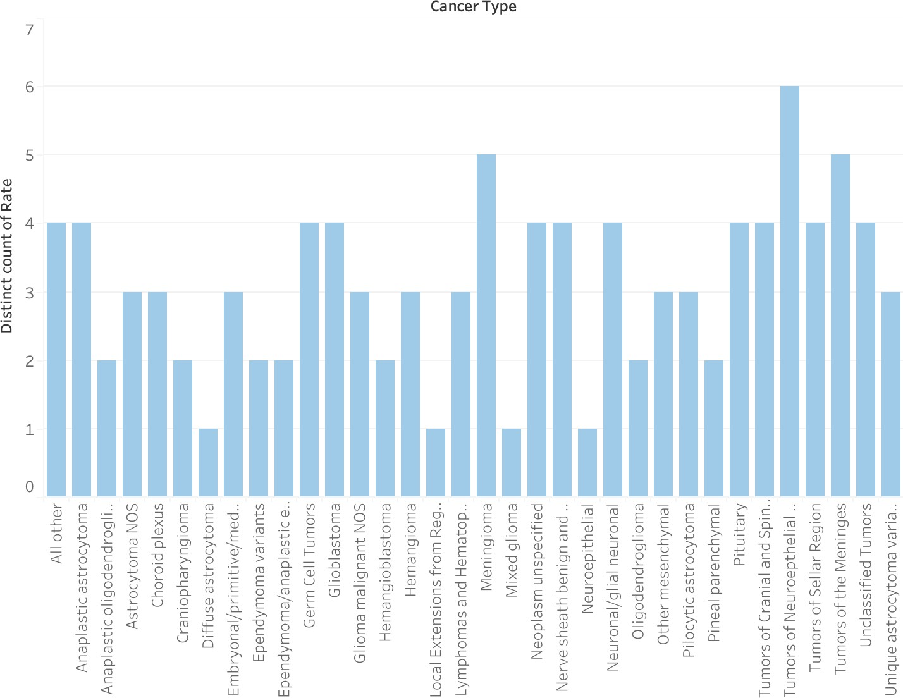

**(Fig.2) Cancer Rate in Male in the year 2018**

Fig. 2. shows the outcomes of data extraction and analysis of cancer Rate in the Male gender in the year 2018. As we can clearly see, Tumors of the Neuroepithelial Tissue have the highest rate among all the cancer types, followed by tumors of the Meanings in the second position.

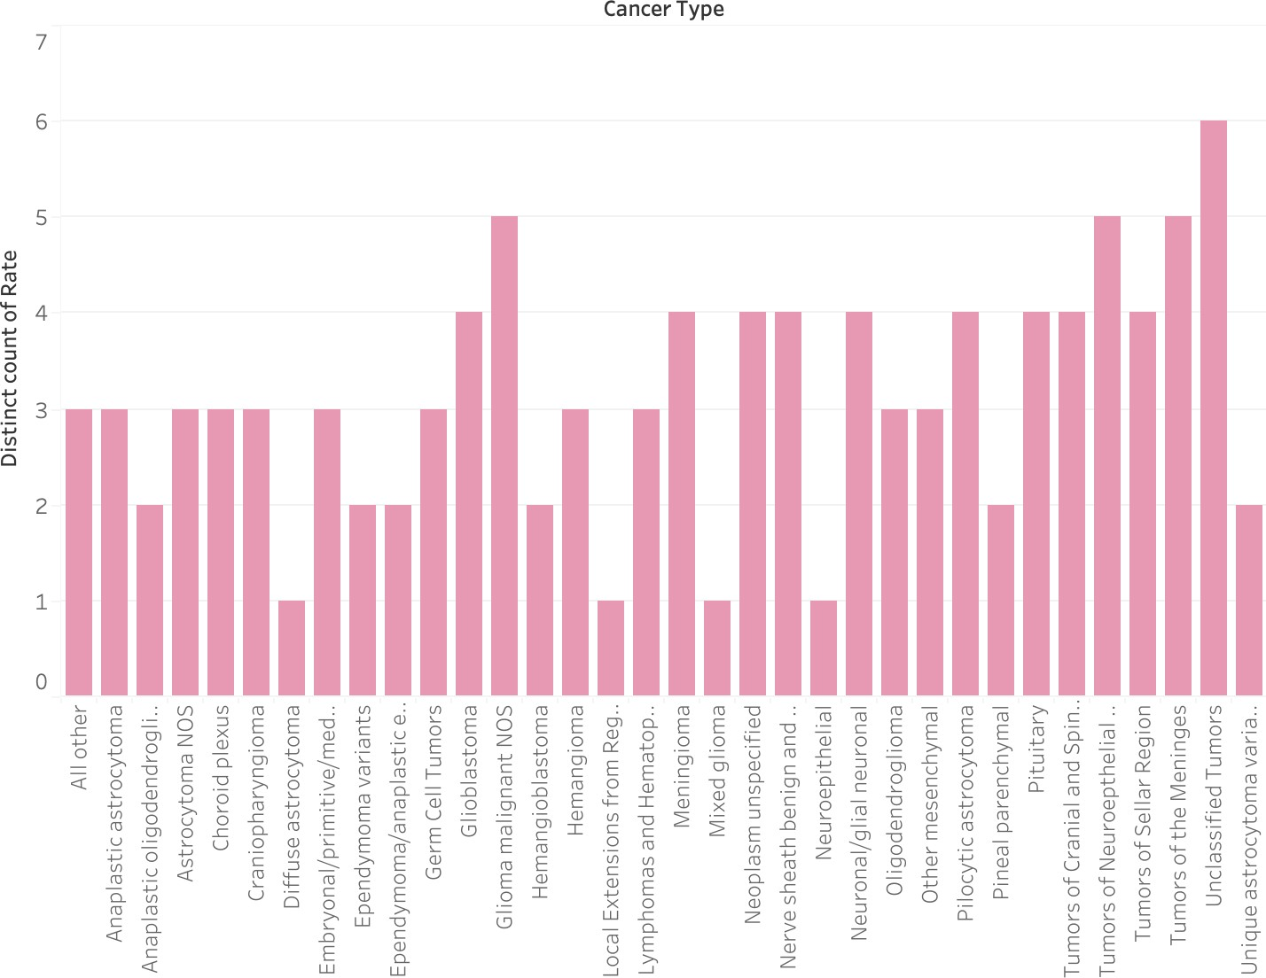

**(Fig.3) Cancer Rate in Female in the year 2018**

The result of extracting the female data analysis displayed in Fig. 3 shows the cancer types and rates that have been reported in the year 2018. From the diagram, the highest rate appears in Unclassified Tumors followed by Glioma Malignant NOS, and Tumors of the Neuroepithelial Tissue.

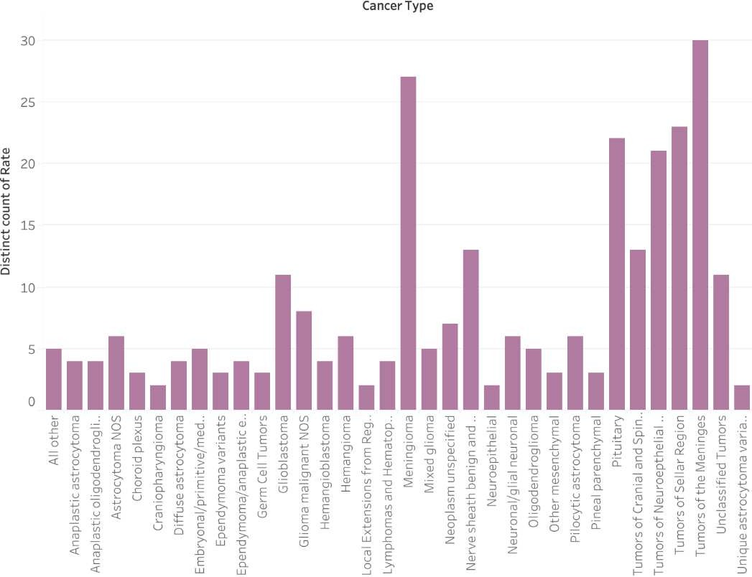

**(Fig.4) Cancer Rate in Females and Males for all the year between 2004 to 2018**

In the above figure, we can see the data analysis outcomes for extracting cancer rates for both genders for all the years between 2004 to 2018. The result shows that Tumors of the Meanings have the most remarkable rate, followed by Meningioma cancer type.

**(Fig.5) ‘Glioma’ Cancer type for females and Males above 20+ age in 2018.**

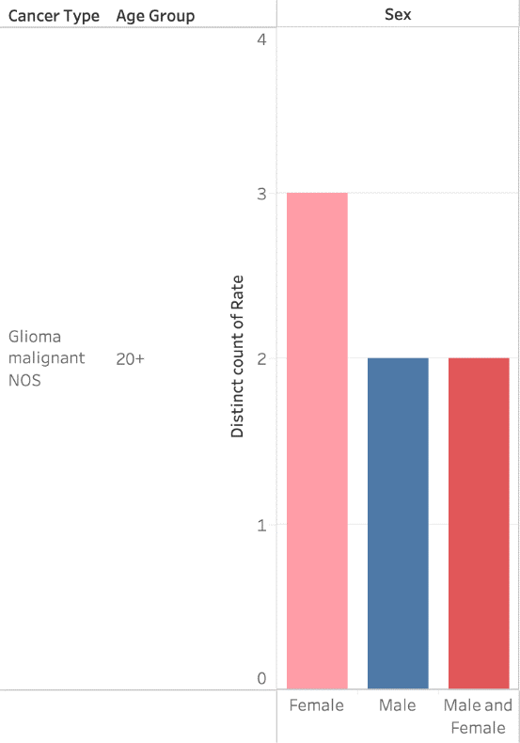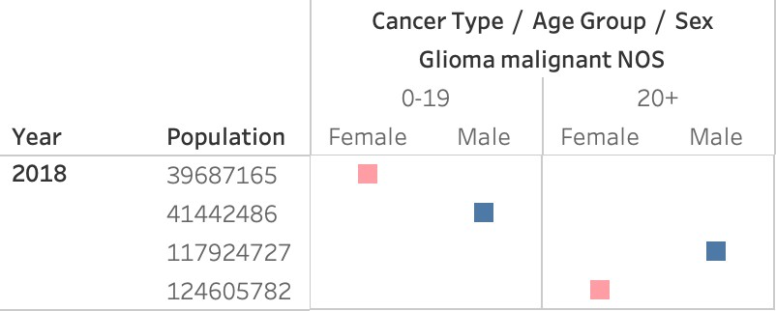

**(Fig.6) The Population of ‘Glioma’ Cancer type for Females and Males from all age groups in 2018.**

A visual analysis study for the 'Glioma cancer type was carried out to find which age groups and gender are more likely to get this type of cancer in recent years. The above figures represent the statistical data associated with the Giomaa cancer type in 2018. According to the reported information that has been collected in the dataset, females above the age of 20 have the highest rate of Glioma cancer. Additionally, the population of the diagnosed female with this cancer type was increased in 2018.

### Additional increment: By using spar: for the USCS Dataset

We are installing and configuring the spark environment for data preprocessing using google Collab. The analysis is conducted on the USCS dataset.

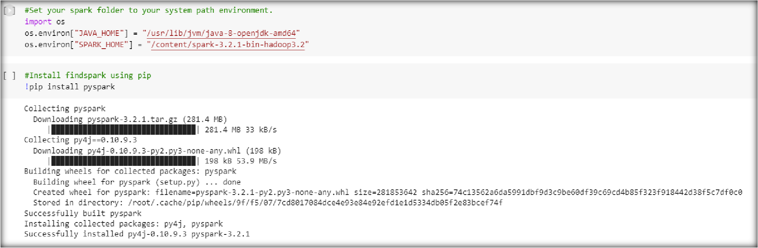

* + - Loading the Brain Tumor Dataset

We loaded the dataset for computation using pyspark. Dataset consists of two target classes namely malignant and benign.

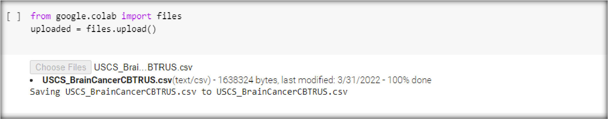

This was faster, and less complicated when compared to that of using Hive for loading the dataset.

* + - Results by using Spark

Reading the loaded dataset and summarizing it using pyspark. In this part, we are listing out the cancer type from the sample population as shown below in the output.

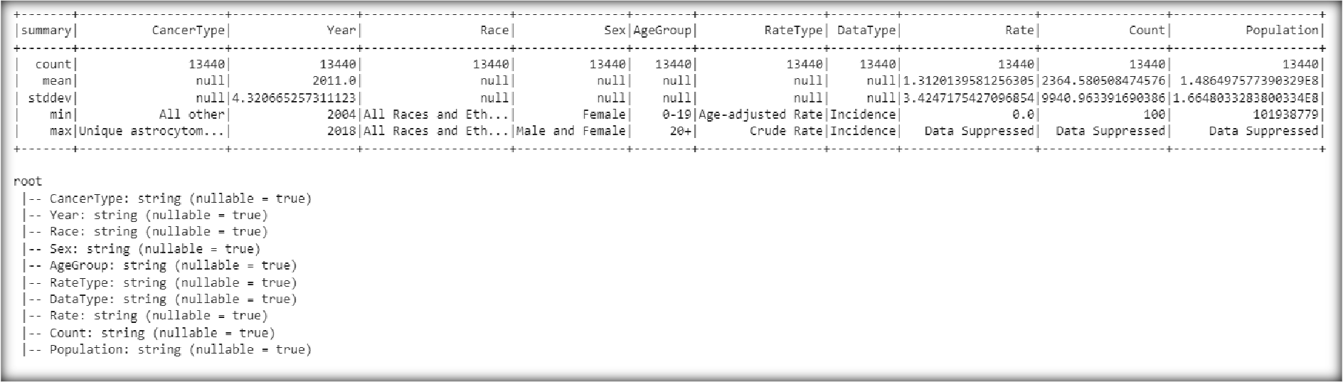

Creating a spark data frame from the given dataset for formatting the given dataset

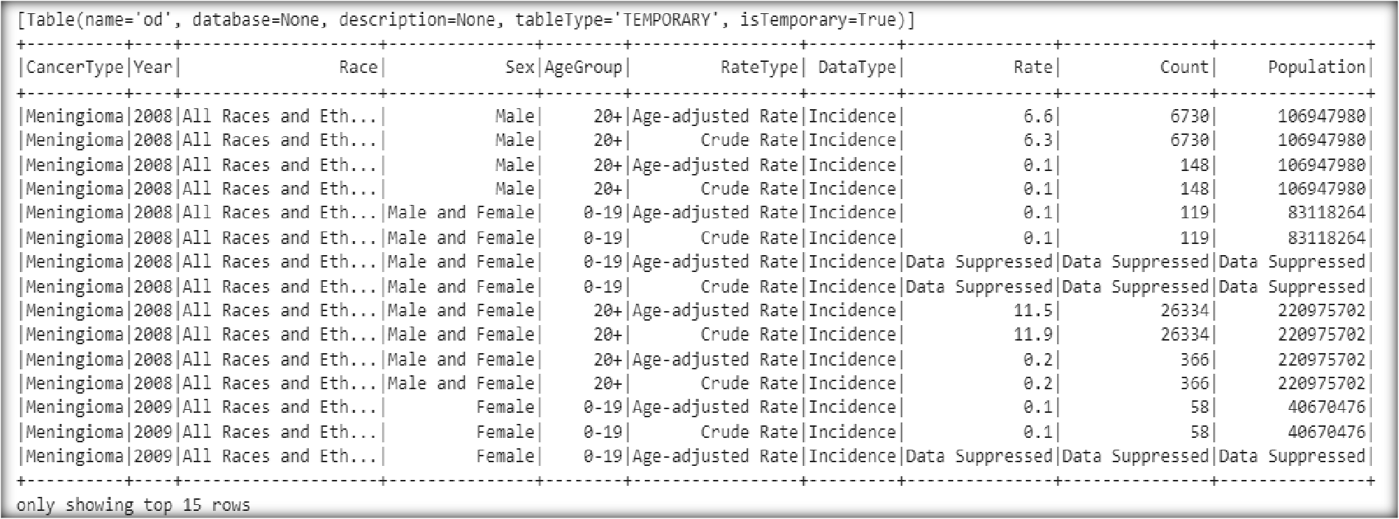

Finding the exact number of classes from the dataset using below commands

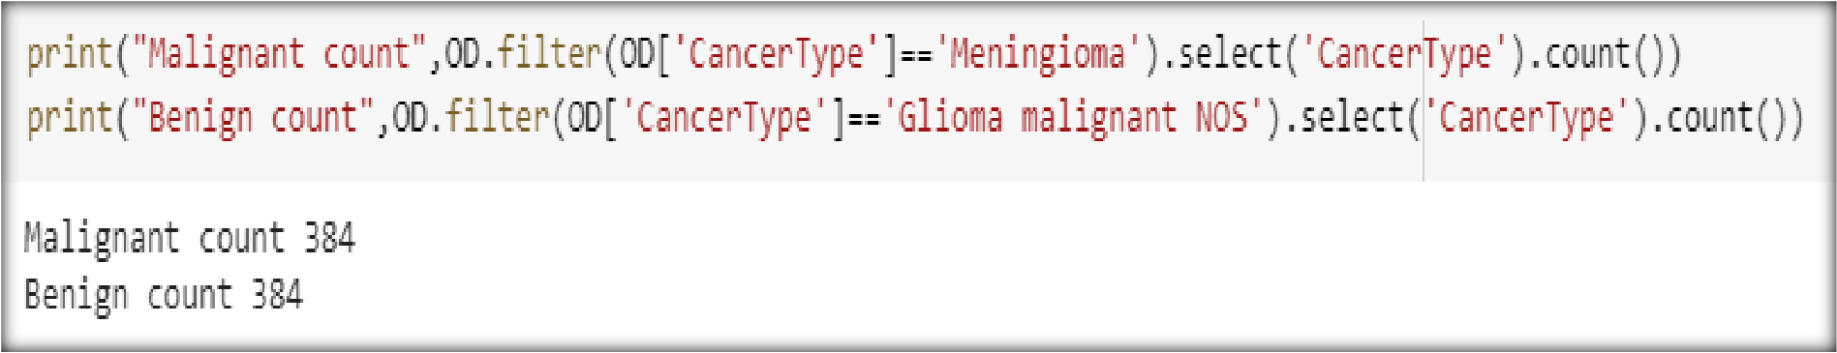

Getting statistical values by dropping unwanted columns these values are useful for normalization

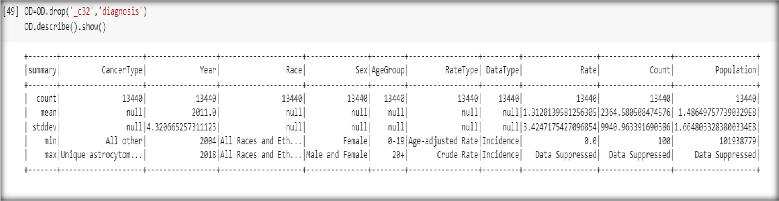

Constructed a scatter plot based on reference points from the given dataset for the year 2004 to 2018

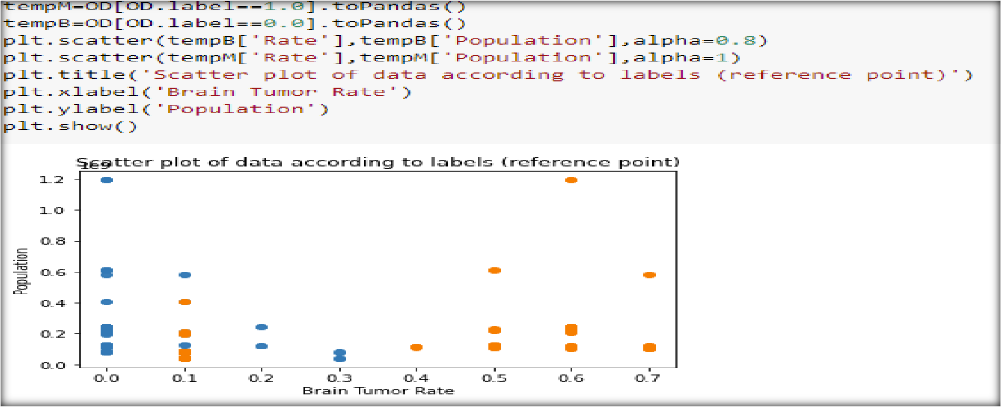

### Data preparation for the analysis of MR images:

The data is trained with T2-weighted images, in which each of the subjects will comprise roughly 155 T2-slices with the dimension of 240*240 pixels. The images are normalized to a unit variance and a zero-mean. We need to remove the first and the last two slices of tumor for each image which is detected from appending it to the list of trained dataset.

Augmentation: three augmented images will be concatenated to each of the T2-slice by flipping each of the slices from left to right horizontally, from upside down vertically and again flipping

horizontally. For each of these binary labels will be generated from the WT mask. All of these are zipped before using and is provided as input data.

2d augmentation of data: in this algorithm, we make us of keras library which is inbuilt function which can be used for taking the tumor slices and their labels as inputs. Augmentation parameters such as rotating the image by 30%, changing the width and the height by 20%, zooming of the slices by 10-30% were all applied on the images. If the T2 slice was initially labeled as 1, all its augmented images corresponding to the slices are also labeled as 1. Three data augmentation steps are being performed on each of these slices and the training cases are concatenated.

3d augmentation of the data: the tumor mask is augmented using the library function keras as performed in the previous step. If there is at least 5 % of the tumor voxels present in the tumor mask post augmentation, then other MR image contrast such as T1, T2, T1c, and FLAIR will be augmented with the same seed.

**Detail Design process*:*** Algorithms to be used for slice-wise detection are Support Vector Machine (SVM), Decision Tree (DT), and Random Forest (RF).

In this project analytics part, we are using the BraTS dataset for detecting the tumor slices in the MR images. From the problem statement we can understand this problem is a supervised learning category in machine learning. It is a classification problem. It is a kind of problem where the outputs are categorical in nature like ‘Yes’ or ‘No’, ‘True’ or ‘False’, ‘0’ or ‘1’. So the algorithm which we plan to use in the first phase is a Random Forest algorithm.

Random forest is a method that operates by constructing multiple decision trees during the training phase. The decision of the majority of the trees is chosen by the random forest as the final decision. Each branch of the decision tree represents possible decision and occurrence.

We make use of a confusion matrix here because classification models have multiple output categories. Most errors will tell us the total error in our model but we cannot use it to find out individual instances of errors in our models. Also, to overcome the limitations of the accuracy. If there is a significant class imbalance, a model might predict the majority class of all cases and have a high accuracy score. It is a table layout of different outcomes of predictions and results of the classification problem and helps us to visualize the outcomes. The accuracy is used to find the portion of correctly classified values it tells us how often our classifier is right.

## IMPLEMENTATION:

### Algorithm:

The network is trained with T2 weighted image on the network. We are using the cases from the BraTS dataset (~25 cases) for the preliminary results using the Keras package in python and running the code on the google Collab. We have loaded on the datasets of the MR images to the google drive and using it for training the machine.

First, we need to prepare the data, it is in the data_preparation.py file. First we need to import all the required libraries such as warnings, sys, os, shuffle from random, numpy, from sklearn.metrics we import accuracy_score, precision_score, recall_score. The first function is to normalize the data where the zero mean and the unit variance is calculated. Next we prepare the data for augmentation, where each of the data is taken as input and labels are given for each of the subjects. Next function is to obtain the data and the tumor mask. For every subject in the input, we create a T2_path where all the t2 images are grouped and the WT mask data is _seg data. Each of these are split and concatenated with the subject ID. Next we prepare the data for each of the subject in the flist.

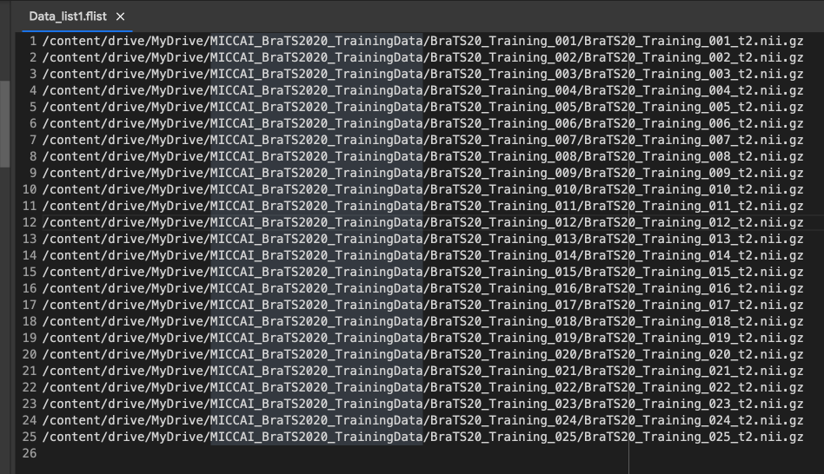

From the input data set, we need to create the flist which has the t2 images of all the subjects before running the code and the path is provided as the input for the code. For the training code, we import the input function, RandomForestClassifier, precision_score, recall_score and the confusion_matrix. Each of the subjects in the flist will be read one by one and a list will be created, and data is prepared with the subject list along with the labels. An array with the data and the labels will be generated. Once the input data is prepared, we do the augmentation and then the Random Forest Classifier will be called and accuracy, sensitivity and specificity will be calculated.

Improvements:

1. The main issue we faced in the first increment was the memory problem, the more number of subjects we used, always crashed when the number was more than 25. We tried to implement the same with google collab pro, which did not work.

We changed a few parameters to overcome this issue, and we were able to run the algorithms on 135 subjects using pycharm.



When, we are preparing the data, we added a new parameter case to read and kept of increasing the value for each time.

1. We also used to pick the images in the order the data was stored and flist was being prepared. Now, we make use of the shuffle function to pick the subjects in random order.
2. Earlier, we implemented on the Random Forest algorithm, now we are using two other algorithms which is stochastic gradient descent (SGDClassifier) and the Kmeans algorithms.

As a result, we implement numerous machine learning models to evaluate their performance on our Dataset. The following are summaries of the classification algorithms utilized in our project:

* 1. **Random Forest (RF)** is an ensemble model that fits many decision tree classifiers on a range of subsets during the training phase before taking the average of the classifiers' performance. This allows for a more accurate prediction score while avoiding overfitting. This model's parameters are set by default. RF model has been tremendously effective as a general-purpose classification and regression approach [13].

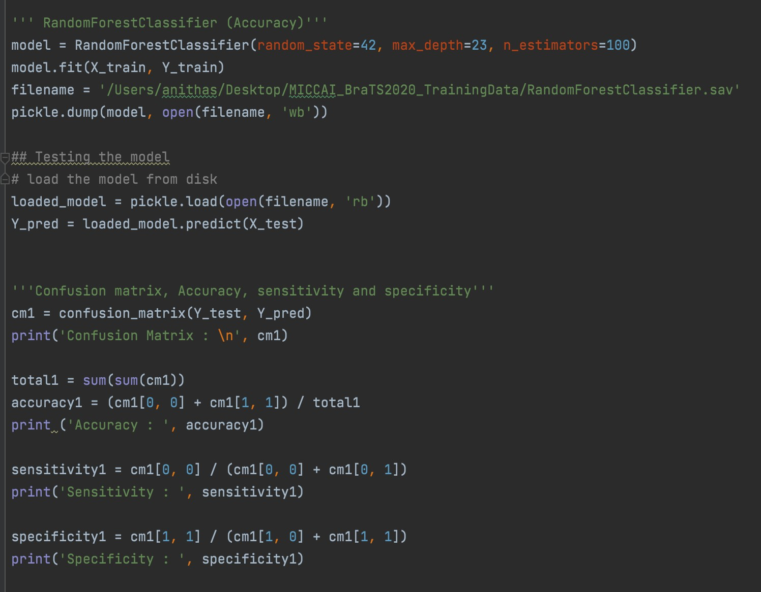

* 1. **Stochastic Gradient Descent (SGD classifier)** aim to optimize the distance between categories by mapping training cases onto high-dimensional space. As a result, even if the number of dimensions exceeds the number of instances, the model may perform well in high- dimension datasets. It has been used in the gene expression profile generated from a tumor sample or peripheral fluid to provide a diagnosis[15]

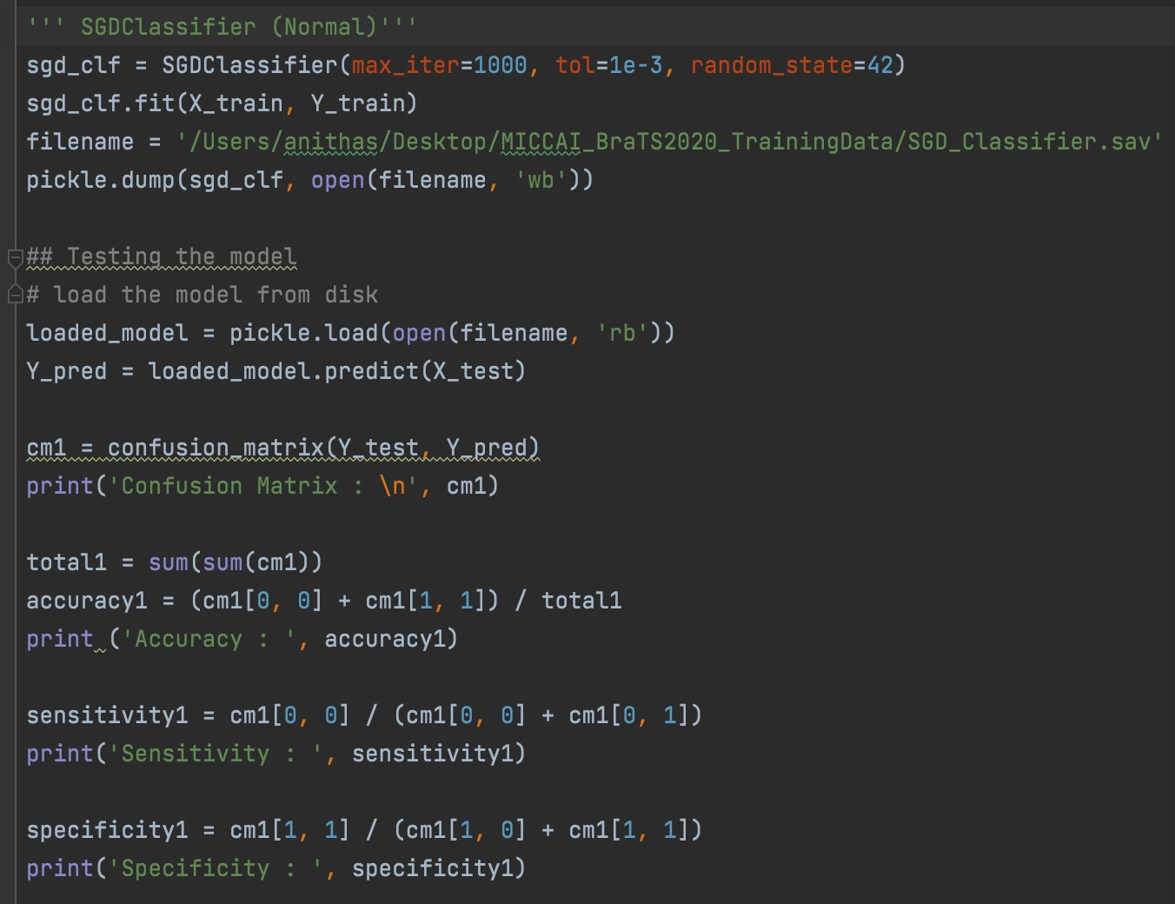

* 1. **K-Nearest Neighbors (KNN)** classify new data points depending on the existing data points that are closest to them. The label of the predictive data point is classified based on the majority vote of k closest neighbors. The number of k neighbors that we chose was k=3.

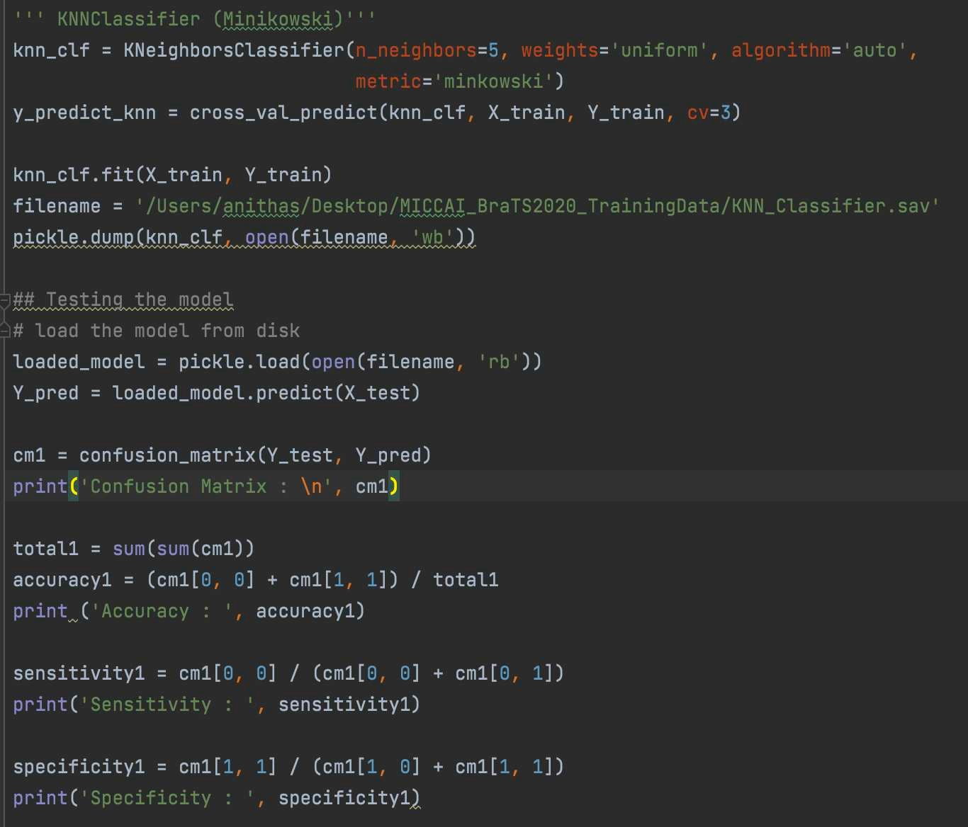

The models' evaluation is done using the most often used assessment metrics to evaluate the machine learning models’ performance. We utilize recall, accuracy, specificity, and sensitivity scores to assess

performance in each model. The accuracy is used to find the portion of correctly classified values. It produces information about how the classifier is successfully classifying the test data.

A confusion matrix is also used to compare anticipated values to actual target values for each model. We make use of a confusion matrix because classification models have multiple output categories. Most errors will tell us the total error in our model, but we cannot use it to find out individual instances of errors in our models. Also, to overcome the limitations of accuracy. If there is a significant class imbalance, a model might predict the majority class of all cases and have a high accuracy score. It is a table layout of different outcomes of predictions and results of the classification problem and helps us to visualize the outcomes.

**RESULTS:**

* + - Random forest:

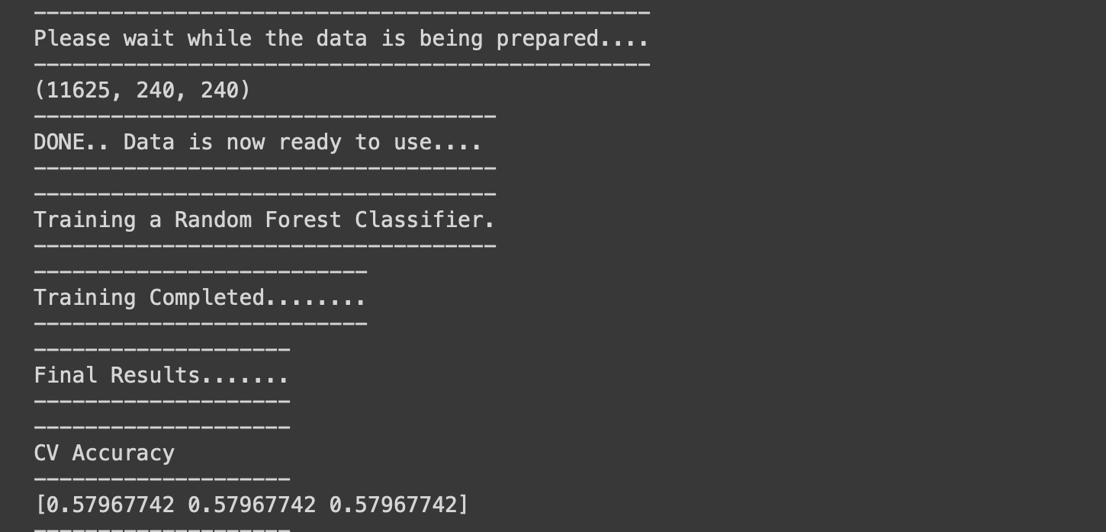

We can see that, the result obtained for 135 subjects is 0.5796 accuracy for the Random Forest Classifier.

* + - SDG Classifier:

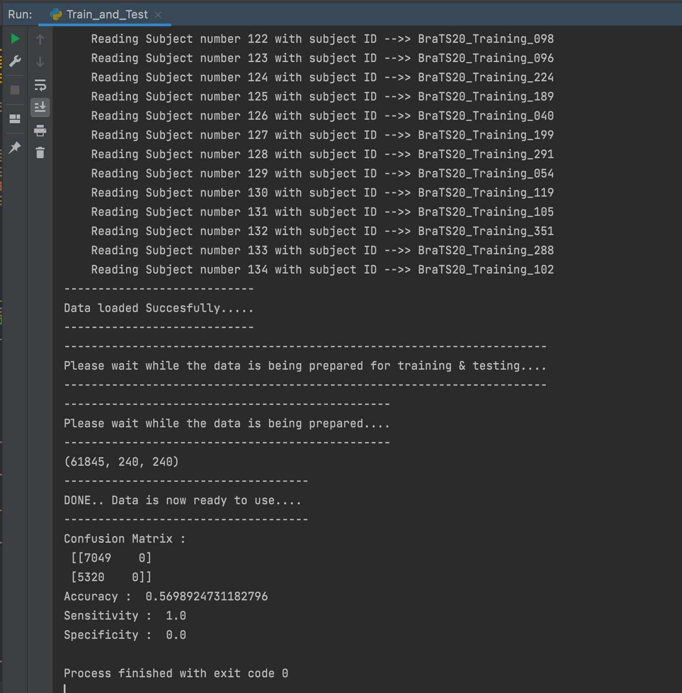

We can see that, the results obtained from running the SDG classifier algorithm is , 0.5698 accuracy, which means it is 57% accurate. And the sensitivity is 1.0 and the specificity is 0.0

* + - KNN classifier:

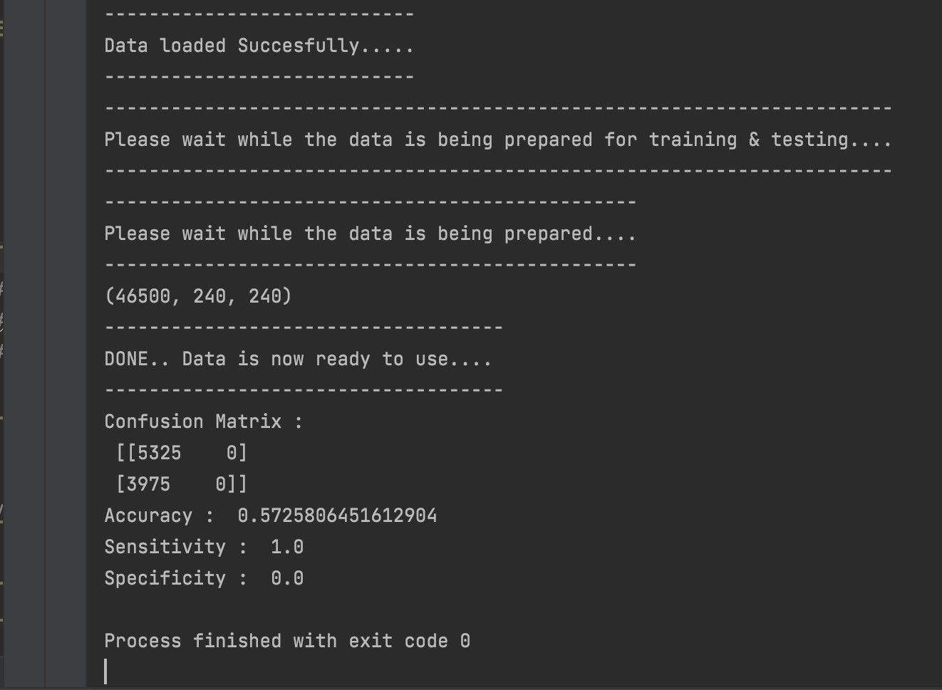

For the KNN classifier we can see that, the accuracy is 0.5725 , which means it is 57% accurate and the sensitivity is 1.0 and the specificity is 0.0

From the above results obtained we can see that, the Random Forest algorithm performs better than the other two algorithms.

**PROJECT MANAGEMENT:**

### Responsibility and Contributions:

Since it contains two datasets, we got divided into two people among four. And worked on Data Analysis and Data Analytics. Below is the report on each of our performances,

|  |  |  |  |
| --- | --- | --- | --- |
| Member Name | Contribution Description | Overall contribution (%) | Notes |

|  |  |  |  |
| --- | --- | --- | --- |
| Anitha | Identified the dataset for the data analysis. Designed the flowchart and execution of the project and the related background study. Took care of data pre-processing in Analytics. Worked with data analytics part like code, writing scripts in ML for the random forest classifier and the SDG classifier. contributed towards the documentation and report preparation | 25% |  |
| Udayasri | Designed Flowchart for Data Analysis and explained each  segmentation of it. Worked with Vandana closely on the remaining Queries. Explained Project Management and framing the document. Worked on implementing the data analysis on SPARK. From previous case study worked on Architecture, workflow part and described it briefly. | 25% | Vandana and Udayasri together contributed for the overall work on the data analysis part starting with identifying the dataset cleaning loading and querying the sample data using hive and SPARK and worked on the complete documentation for the analysis part. |
| Vandana | Identified the relevant dataset for the analysis part and cleaned the data.  Loaded data in Hadoop, wrote hive queries for sampling the data. Worked with Udayasri on the content for documenting the analysis part for increment -1. For final submission worked on data preprocessing implementing the data analysis using pyspark. Performance analysis and visualization was done for documentation of this project. | 25% |

|  |  |  |  |
| --- | --- | --- | --- |
| Asmaa | Searching for an appropriate datasets Writing initial questions along with their queries in the analysis part.  Uploading data in Tableau, extracting the data, and creating all the visualization charts. Working on the Image data extraction and preprocessing for the data Analytics part. Worked on the machine learning algorithm KNN classifier. Writing the Data Analysis Results, Project Background, Dataset description, and Machine learning implementation parts on documentation. | 25% |  |

### Work completed:

Analysis: For Data Analysis part, loading of the data and preprocessing of the data

has been completed. we have executed 10 different queries for the data analysis and performed visualization for 5 queries executed. Also implemented the same using spark and we found that running on spark for the data analysis is faster and better compared to that of the HIVE environment.

Analytics: We have executed the code using the first 25 subjects and obtained a result of 57 accuracy using the random forest method. We implemented Random forest with the accuracy of 57 and SDG classifier with the accuracy of 56 and the KNN classifier with the accuracy of 57. Out of it all, we can see that the Random forest is better compared to the other algorithms.

* + - **Issues faced:** due to large dataset, we need higher RAM for training the machine, which we are trying to solve it using other techniques. We were able to work with 25 subjects for the first increment and 135 Subjects for the second increment.

## REFERENCES

1. Yogananda CGB, Shah BR, Vejdani-Jahromi M, et al. A fully automated deep learning network for brain tumor segmentation. *Tomography* 2020;6:186-193
2. Shreyas V, Pankajakshan V. A deep learning architecture for brain tumor segmentation in MRI images. *2017 IEEE 19th International workshop on multimedia signal processing (MMSP)*: IEEE; 2017:1-6
3. Pei L, Reza SM, Li W, et al. Improved brain tumor segmentation by utilizing tumor growth model in longitudinal brain MRI. *Medical Imaging 2017: Computer-Aided Diagnosis*: SPIE; 2017:666-674
4. Kamnitsas K, Bai W, Ferrante E, et al. Ensembles of multiple models and architectures for robust brain tumour segmentation. *International MICCAI brainlesion workshop*: Springer; 2017:450-462
5. Menze BH, Jakab A, Bauer S, et al. The multimodal brain tumor image segmentation benchmark (BRATS). *IEEE transactions on medical imaging* 2014;34:1993-2024
6. Bakas S, Akbari H, Sotiras A, et al. Advancing the cancer genome atlas glioma MRI collections with expert segmentation labels and radiomic features. *Scientific data* 2017;4:1-13
7. Bakas S, Reyes M, Jakab A, et al. Identifying the best machine learning algorithms for brain tumor segmentation, progression assessment, and overall survival prediction in the BRATS challenge. *arXiv preprint arXiv:181102629* 2018
8. U.S. Cancer Statistics Working Group. U.S. Cancer Statistics Data Visualizations Tool, based on 2020 submission data (1999-2018): U.S. Department of Health and Human Services, Centers for Disease Control and Prevention and National Cancer

Institute; [www.cdc.gov/cancer/dataviz,](http://www.cdc.gov/cancer/dataviz) released in June 2021.

1. S. Bakas, M. Reyes, A. Jakab, S. Bauer, M. Rempfler, A. Crimi, et al., "Identifying the Best Machine Learning Algorithms for Brain Tumor Segmentation, Progression Assessment, and Overall Survival Prediction in the BRATS Challenge", arXiv preprint arXiv:1811.02629 (2018)
2. https://[www.cancer.org/research/cancer-facts-statistics/all-cancer-facts-figures/cancer-](http://www.cancer.org/research/cancer-facts-statistics/all-cancer-facts-figures/cancer-) facts-figures-2021.html
3. Nadeem, M. W., Ghamdi, M. A. A., Hussain, M., Khan, M. A., Khan, K. M., Almotiri,

S. H., & Butt, S. A. (2020). Brain tumor analysis empowered with deep learning: A review, taxonomy, and future challenges. Brain sciences, 10(2), 118.

1. Arumaiththurai, T., & Mayurathan, B. (2021, August). The Effect of Deep Learning and Machine Learning Approaches for Brain Tumor Recognition. In 2021 10th International Conference on Information and Automation for Sustainability (ICIAfS) (pp. 185-190). IEEE.
2. Biau, G., & Scornet, E. (2016). A random forest guided tour. Test, 25(2), 197-227.
3. Kingsford, C., & Salzberg, S. L. (2008). What are decision trees?. Nature biotechnology, 26(9), 1011-1013.
4. Noble, W. S. (2006). What is a support vector machine?. Nature biotechnology, 24(12), 1565-1567.